1st Page:

AAPL logo, ATC logo, GC EPC logo with hand symbol

Home

Contact

Enquiry

**Home**

About Us

PEB Division

PEB AMC

PEB Accessories

EPC Solutions

Project Galley

Join us

Downloads

**Contact**

Corporate Office:

AadityaPebsol Private Limited

C-17/2A, Industrial Estate

Moulali, Hyderabad-500040

Email: contact@aadityapebsol.com

www.aadityapebsol.com

Tel: 040.2724.7337 / 8337

Manufacturing Facility:

1. **Built-up**

AadityaPebsol Private Limited

197,198/b & 251/9, NH-7, Boothpur (Mandal)

Mehaboobnagar (Dist.), Telangana-509301

2. **Secondary & Accessories**

AadityaPebsol Private Limited

Plot No.126/C, IDA Bollaram

Hyderabad-500072

**Warehouse:**

Aditya Trading Corporation

C-17, Industrial Estate, Moulali

Hyderabad-500040

Sales:

South

Mr Anil Shripat Sangare

Mobile: 91000.70730

Email: [anil@aadityapebsol.com](mailto:anil@aadityapebsol.com)

West

MrSukantaGhosh

Mobile: 91000.70720

Email: [sukanta@aadityapebsol.com](mailto:sukanta@aadityapebsol.com)

Ethics Complaints:

[ethicscounselor@aadityapebsol.com](mailto:ethicscounselor@aadityapebsol.com)

AMC

MrSubrataGhosh

Mobile: 91000.70724

Email: [amc@aadityapebsol.com](mailto:amc@aadityapebsol.com)

**About us**

Introduction about APPSL

Introduction & Hyperlink on ATC

Introduction & Hyperlink on GV EPC

**PEB Division**

1. PEB (Pre-Engineered Building)
2. Primary members / Main Frames
3. Secondary members / Cold Formed Members
4. Roof & Wall Panels
5. Insulated Sandwich Panels
6. Installation & Technical Advisory Services
7. Advantages of AadityaPebsol Products
8. Comparative Study (PEB vs Traditional)
9. Other Products & Services
   1. Structural Steel
   2. Storage Solutions
   3. Cold Rolled Formed Buildings
10. Submit Enquiry (Form to be developed & link file uploading file)

**PEB AMC**

1. Preventive Maintenance of PEB leakage
2. Storm water management
3. Repair/Rehabilitation

**PEB Raw Material**

1. Hot Rolled Coils/Plates
2. Cold Rolled Coils/Sheets
3. Bare Galvalume Coils
4. Pre-Painted Galvalume Coils
5. Pre-Painted GI Coils
6. Hot Rolled Builtup Sections
7. Hot Rolled Bars
8. Paints
9. Abrasive wheels
10. Welding Consumables
    * 1. Flux
      2. Welding Wires

**PEB Trading**

1. Purlins / Girts
2. Eve Sturts
3. Roof Panel –Trepezoidal Profiled Sheet
4. Roof Panel – Standing Seam Profile Sheet
5. Wall Cladding Profiled Sheet
6. Trims & Flashing

**PEB Accessories**

1. Self Drilling Screws
2. Rope Seal Tape / Butyl Tape / Mastic Tape
3. Silicon Sealants
4. Rivits
5. Retrofits
6. In-side / out-side closures
7. Insulation – Bubble
8. Insulation – Glass Wool
9. Insulation – Rock Wook
10. Weld mesh
11. Life Line System
12. Wind Ventilator
13. Power Ventilator
14. FRP profiled Base for ventilator
15. Polycarbonate Skylight
16. Connection Bolts
17. Deck Sheet Studs & Deck Nail
18. Anchors
    * 1. PEB Anchor Bolts
      2. Mechanical Anchors
      3. Chemical Anchor Stud

**EPC Solutions**

1. Turnkey Project Management
   1. Single Point Contract Responsibility
   2. Centralised Logistic Control
   3. Centralised Site/Project Control
2. Customised Value Addition
   1. Auditoriums
   2. Convention Halls
   3. Architectural Versatility

**Project Gallery**

Project-wise photos

Immediate as per exhibition

**Join Us**

Vendor Registration

Builder Registration

Labour Contractor Registration

Careers with Aaditya Group

About us

**AadityaPebsol**is a leading manufacturing company based at Hyderabad and offers Engineering, Fabrication, Supply and Erection of Pre-Engineered Steel Buildingsolutions. We provide complete and customized building solutions.

Aaditya Group is Established under Dynamic individual professional having 22 years of experience in Engineering, Procurement, & Sales in multi-national manufacturing industries. Under their leadership, the organization has grown manifold. Enriched with an experience of over one decade, today, AadityaPebsol is one of the fastest growing companies strong in the south & west part of the country. The company has reputed/repeated clientele. The strict quality control measures, adoption of most modern and state-of-the art technology, innovative concepts and adhering to strict delivery schedules have made AadityaPebsol today the most trusted name in the industry.

**Aaditya Group is known for Transparency, Commitment & Ethics.**

Have dedicated Sales, Engineering, Operations, Procurement, Logistics, Safety, Construction in-charge to look after fulfillment of order management, supply & construction.

in the respective businesses along with Project Management for Building Solutions and Supply Chain for Building Products and Distribution to look after generation and fulfillment, order management and supply chain management.

**Aditya Trading Corporation** is a part of Aaditya Group satisfactorily serving customers in PEB Accessories as one-stop-shop for PEB Manufacturers, Fabricators & Contractors. Aditya Trading Corporation operating from Hyderabad and trading all PEB accessories listed below:

* Self Drilling Screws& Rivets
* Rope Seal Tape / Butyl Tape / Mastic Tape
* Silicon Sealants
* Retrofits
* In-side / out-side closures
* Insulation
* Weld mesh
* Life Line System
* Ventilators
* Louvers
* FRP profiled Base
* Polycarbonate Skylight
* Connection Bolts
* Decking Studs &Nails
* Anchors

The product are serviced directly and through channel partners spread across country.

Aditya Trading Corporation has dedicated staff to manage the customer orders to manage their finances effectively by supplying just-in time. Dedicated staff will plan all the material as per the customers and keeps them ready on shelf for dispatch as per the dates through its specially developed ERP system. ERP tracks the customer orders and gives daily alters to the team for planning the materials. Dependability on Aditya Trading Corporation for PEB Accessories will help reduce the inventories with the customers and reduce the holding cost. Aditya Trading Corporation will hold the stocks for regular customers as per the ERP analysis at least 3months for each customer.

**GV EPC**

GV EPC  operate with a team of dedicated professionals working at various locations. GV EPC is a provider of turnkey pre-engineered metal building systems, offering a one-stop-shop for all projects. Each project is completed within time and cost targets using the highest quality and safety standards followed.

Turnkey project execution improves client-contractor coordination and interface with other site contractors, and allows GV EPC to be the preferred bidder for executing large projects as compared to any other PEB company in the market.

### Project Management at GV EPC:

* Single-point contract responsibility.
* Centralized logistics control.

### Centralized site management and project control

**Values-Vision-Mission as below:**

**Values:** Safety, Trust, Human Dignity and Excellence

**Vision:** AadityaPebsol shall strive to achieve Leadership position in Pre-Engineering Building Business and its applications.

**Mission**:AadityaPebsol will actively pursue market development of PEB Business and its applications by developing customer oriented, reliable and efficient solutions. Our endeavor is to become the most preferred solution provider in PAN INDIA. Safety and Quality shall be the hallmark of all our operations.

**Why Aaditya Pebsol-**

WE NOT ONLY DELIVER THE PROJECT, We Care your Dream Project just like you. Our passion is to create buildings & structures in a way that everyone become spellbound &remember us for forever.

* One of the leading PEB in south & western India.
* On time delivery
* Optimal & Aesthetic Designs
* 100% optimization
* Assured Quality.
* Cost effective.
* ZERO defects.
* Technical competency
* Innovative & Expertise.

**PEB Division**

1. PEB (Pre-Engineered Building)

Pre-Engineered Steel Buildings are manufactured in the plant itself. The manufacturing of structural members is done as per the customer’s requirements. Using steel in an efficient way makes pre-engineered building about 30% lighter than conventional steel structures. Tapered built up sections are provided in primary framing with the smaller depth in areas of lower stress and larger depth in area of higher stress. Light weight cold formed “Z” or “C” shaped sections are provided in secondary members. Possibly no modification can be made at the site at the time of erection such as welding and cutting. No manufacturing process takes place at the customer site.

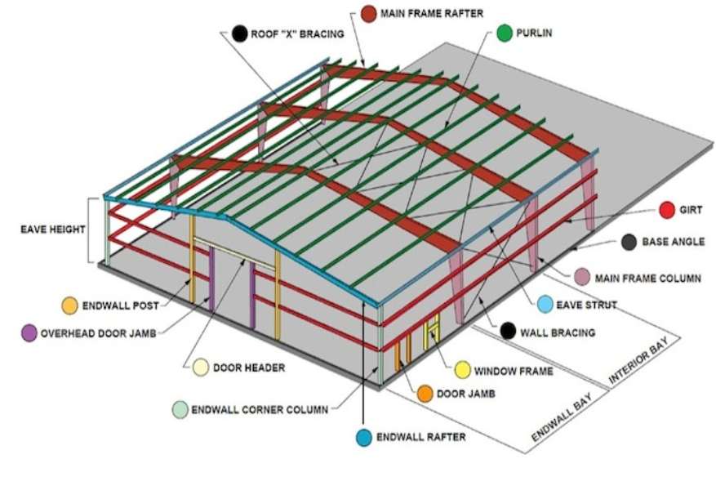

1. Primary members / Main Frames

Rigid steel frames of the building are mainly considered as the Main Frames of PEB. PEB rigid frame comprises of tapered columns and tapered rafters (the fabricated tapered sections are referred to as built-up members). The tapered sections are fabricated using the state of art technology wherein the flanges are welded to the web. Splice plates are welded to the ends of the tapered sections. The frame is erected by bolting the splice plates of connecting sections together.

1. Secondary members / Cold Formed Members

Purlins, Girts and Eave Struts are secondary structural members used to support the wall and roof panels. Purlins are used on the roof; Girts are used on the walls and Eave Struts are used at the intersection of the sidewall and the roof. Secondary members have two functions: they act as struts that help in resisting part of the longitudinal loads that are applied on the building such as wind and earthquake loads, and they provide lateral bracing to the compression flanges of the main frame members thereby increasing frame capacity.

1. Roof & Wall Panels

Roof / Wall panels are manufactured out of high strength steel grade with minimum tensile strength of 550 MPa The steel base is coated with Zinc-Aluminum alloy with minimum AZ150 (150 g/m2 with minimum coating mass) as per ASTM A792.

Color coated Galvalume confirming to ASTM A792 specification has specifically formulated paint system for external roofing and wall cladding application to give aesthetical appearance for long lasting color for much longer time than any other conventional paint system

1. Insulated Sandwich Panels

structural insulated panel, or structural insulating panel, (SIP), is a form of [sandwich panel](https://en.m.wikipedia.org/wiki/Sandwich_panel) used in the [construction](https://en.m.wikipedia.org/wiki/Construction) industry.

SIP is a [sandwich structured composite](https://en.m.wikipedia.org/wiki/Sandwich_structured_composite), consisting of an insulating layer of rigid core sandwiched between two layers of structural board, used as a [building material](https://en.m.wikipedia.org/wiki/Building_material). The board can be sheet metal, plywood, cement, [magnesium oxide board](https://en.m.wikipedia.org/wiki/Magnesium_oxide_wallboard) (MgO) or [oriented strand board](https://en.m.wikipedia.org/wiki/Oriented_strand_board) (OSB), and the core can either be expanded [polystyrene foam](https://en.m.wikipedia.org/wiki/Polystyrene) (EPS), [extruded polystyrene](https://en.m.wikipedia.org/wiki/Extruded_polystyrene) foam (XPS), [polyisocyanurate](https://en.m.wikipedia.org/wiki/Polyisocyanurate) foam, [polyurethane foam](https://en.m.wikipedia.org/wiki/Polyurethane_uses), or be [composite honeycomb](https://en.m.wikipedia.org/wiki/Composite_honeycomb) (HSC).

SIPs share the same structural properties as an [I-beam](https://en.m.wikipedia.org/wiki/I-beam) or I-column. The rigid insulation core of the SIP acts as a web, while the sheathing fulfills the function of the flanges. SIPs combine several components of conventional building, such as studs and joists, insulation, vapor barrier and air barrier. They can be used for many different applications, such as exterior wall, roof, floor and foundation systems.

1. Installation & Technical Advisory Services

In addition to the supply of steel building structures, AadityaPebsol offers erection services through its authorized builders.

AadityaPebsol certified builders have undergone intensive training on erecting buildings of varying complexity and for different applications. APPL certified builders are highly competent and offer skilled expertise to clients. The local APPL certified builder offers comprehensive services from construction to complete turnkey solutions.

APPL provides extensive technical advisory services to its clients - from selection of appropriate structures and economic design to adaptation of local building codes. To ensure excellent quality and customer satisfaction, APPL’s Technical Service representatives monitor and supervise the entire project until completion.

1. Advantages of Aaditya Pebsol Products

Steel exhibits desirable physical properties that make it one of the most versatile structural materials. Some of its properties such as strength, uniformity, light weight, ease of use, etc., make it an ideal choice for construction of bridges, high rises, heavy industrial and power plants, oil & gas, and other structures.

#### The following advantages may be credited to steel as a structural design material:

Optimal & Aesthetic Designs

Steel has a high strength/weight ratio. Thus, the dead weight of steel structures is relatively small. Steel can aid in innovative designs compared to concrete.

Enhanced Speed of Construction

Steel is highly suitable for prefabrication and mass production Steel structures can be erected quite rapidly, resulting in quicker economic payoff.

Earthquake Resistant

Properly designed steel structures can have high ductility, which is an important characteristic for resisting shock loading, such as blasts or earthquakes.

Durability & Flexibility in Expansion

In contrast to reinforced concrete, steel properties do not change considerably with time. Steel buildings can be easily expanded by adding new bays or wings.

Quality of Construction & Ease in Maintenance

Steel structures can be built with high-quality workmanship and narrow tolerances. Steel structures in general can be repaired quickly and easily.

Salvage Value Through Repetitive Use

Steel can be reused after a structure is dismantled.

Site Constraints

Steel is easily transportable and thus can be fabricated in a workshop, which reduces the construction time at site.

1. Comparative Study (PEB vs Traditional)

| Evaluation Criteria | Peb Building | Concrete Building |
| --- | --- | --- |
| Fabrication | Precise fabrication: Members fabricated in a controlled environment and up to 50% saving in fabrication time on site. | Fabrication done on site; Requires building the reinforcement cage and shuttering work prior to pouring. |
| Delivery and Logistics | Can be delivered in desired sequence anywhere in the world. | Might have to build batch plant on site if site is secluded or huge. |
| Installation Time | 50% saving in construction time. Fast Installation with no idle time. | Slow and time consuming: The contractor will have to wait for the previous cast to harden (14-28 days) before being able to cast next batch. |
| Quality | Quality of steel is guaranteed because   * It is a homogeneous product. * Pieces are tailored according to shop drawings. * Precise machinery is used for fabrication. * It is fabricated under shop control. * Quality is not affected by weather conditions | Many factors lead to quality deterioration   * Concrete is not a homogeneous product. * Concrete mix ingredient ratios are difficult to maintain. * Quality of water used may vary. * Weather conditions. * Labor experience in pouring. * Adequate use of vibrators. * Using proper curing methods. * Concrete shrinkage. * High manpower count may weaken control. |
| Cost | Savings of 10%-15% for large span steel building. | Construction cost is high at site. |
| Industrial Applications | Saving on maintenance cost: Can easily handle equipment such as multiple cranes within building. Sways can be controlled. Precision can be achieved during installation. | Heavy equipment usage such as cranes is limited. |
| Commercial & Infrastructure Applications | Better aesthetics and longer spans can be achieved using steel as building component. | Limited designs are possible with concrete. |

1. Other Products & Services
   1. Structural Steel

APPL’s structural steel products are custom-designed and workshop fabricated, hot rolled and welded steel structures for applications such as heavy industries, power plants, oil & gas, petrochemical industry, high-rise/commercial buildings, airports and other specialized structures. We are one of the most innovative steel structure fabricators and are always looking to enhance our range of products and services, including project execution.

* 1. Storage Solutions

The Aaditya’s product range includes state-of-the-art storage solutions with a modern modular European design, for a wide range of products. Our storage solutions provide effective storage through maximum storage capacity with optimal floor utilization. Aaditya has a state-of-the-art manufacturing facility at Hyderabad, with 3,000 MT per annum capacity, with an automatic welding facility to ensure narrow tolerances. Aaditya is the perfect partner for your special storage solutions. Aaditya is the right choice for the responsible and busy supply chain manager who believes in safety, reliability, cost effectiveness solution and optimum space utilization.

* 1. Cold Rolled Formed Buildings

Cold-formed steel structural members are shapes commonly manufactured from steel plate, sheet or strip material. The manufacturing process involves forming the material by either press-braking or cold roll-forming to achieve the desired shape. No heat is required to form the shapes (unlike hot-rolled steel), and thus the name ‘cold- formed steel’. Cold- formed steel members and other products are thinner, lighter, and easier to produce, and typically cost less than their hot-rolled steel members.

Cold-formed steel offers versatility in building because of its light weight and ease of handling and use. Cold-formed steel structures framing provides builders and consumers flexibility in design options which cannot be economically accommodated using traditional framing materials (i.e., larger open space, longer spans, and doorways).

##### Consistent Quality

Steel does not contain knots, twists, or warps that are commonly found in lumber. It is always dimensionally correct and manufactured to very strict tolerances.

##### Light Weight

Steel members weigh as much as 40% less than conventional lumber, reducing total building and seismic loads.

1. Submit Enquiry (Form to be developed & link file uploading file)

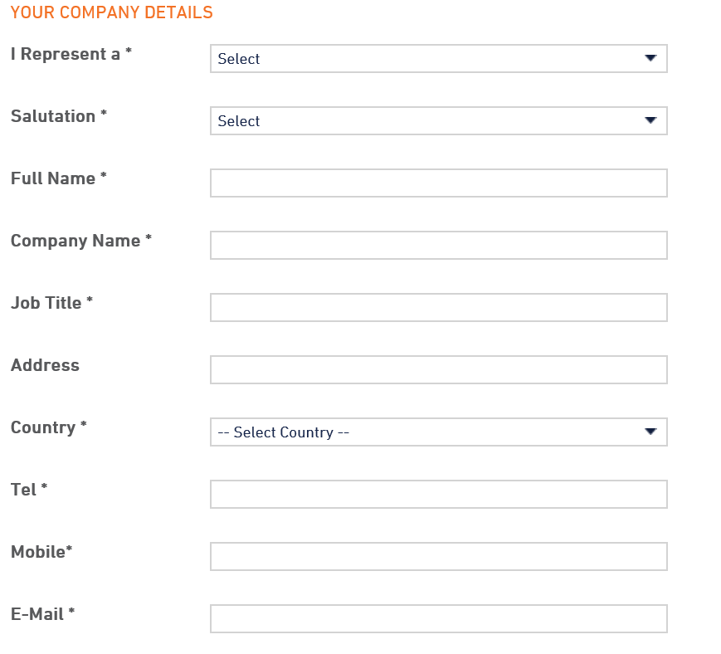

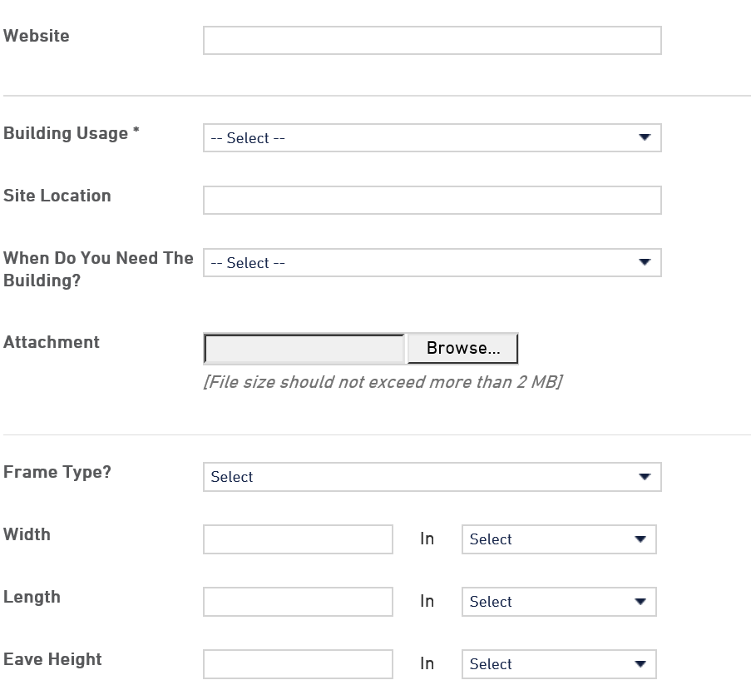

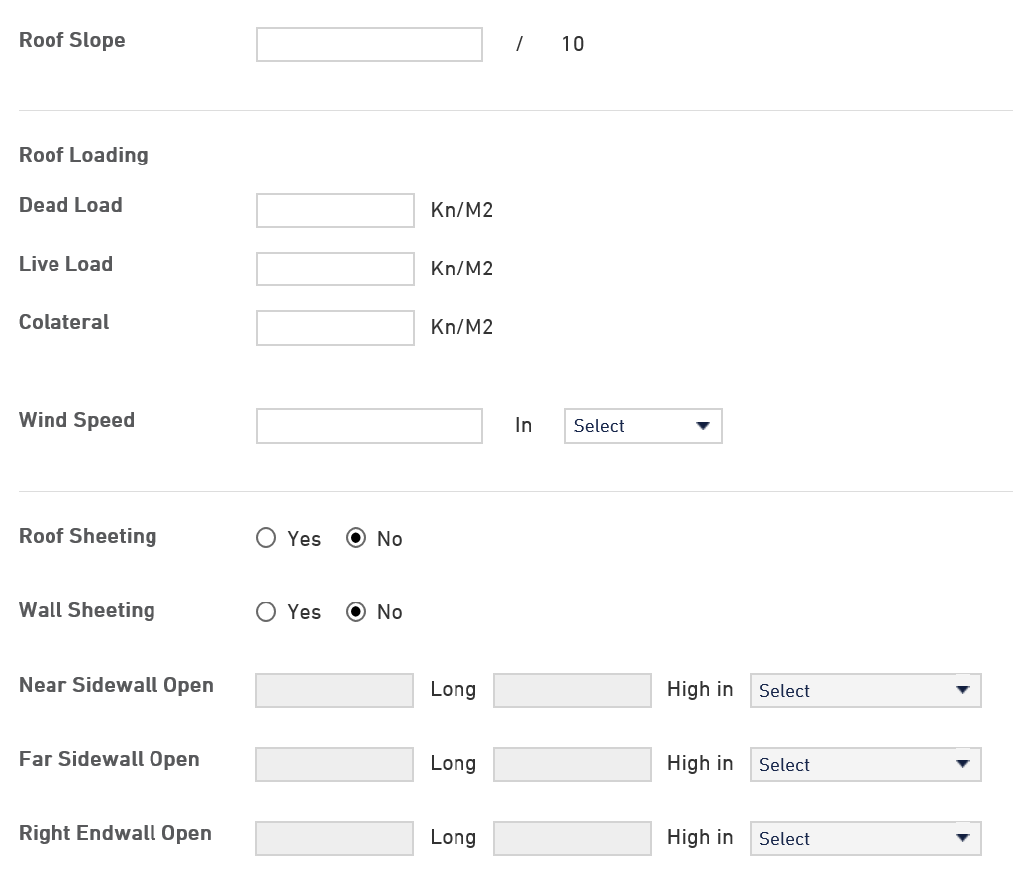

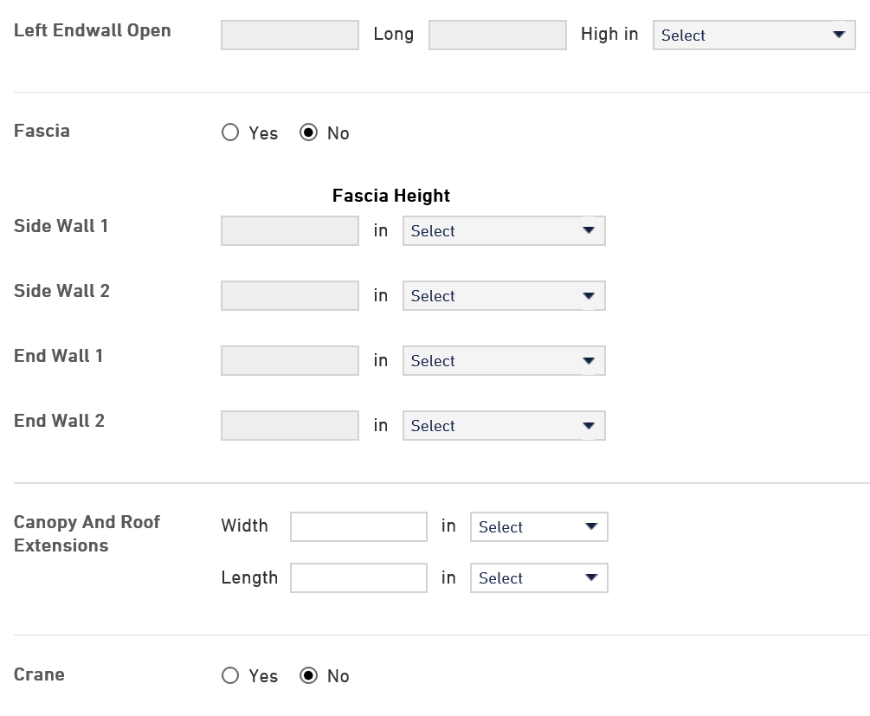

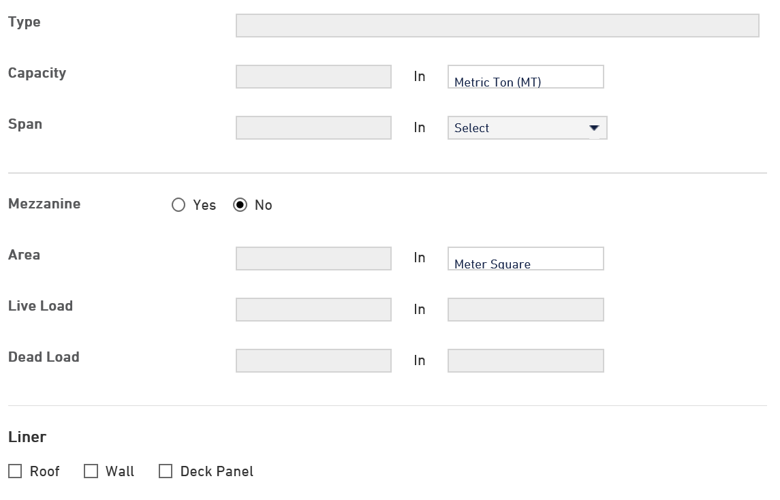

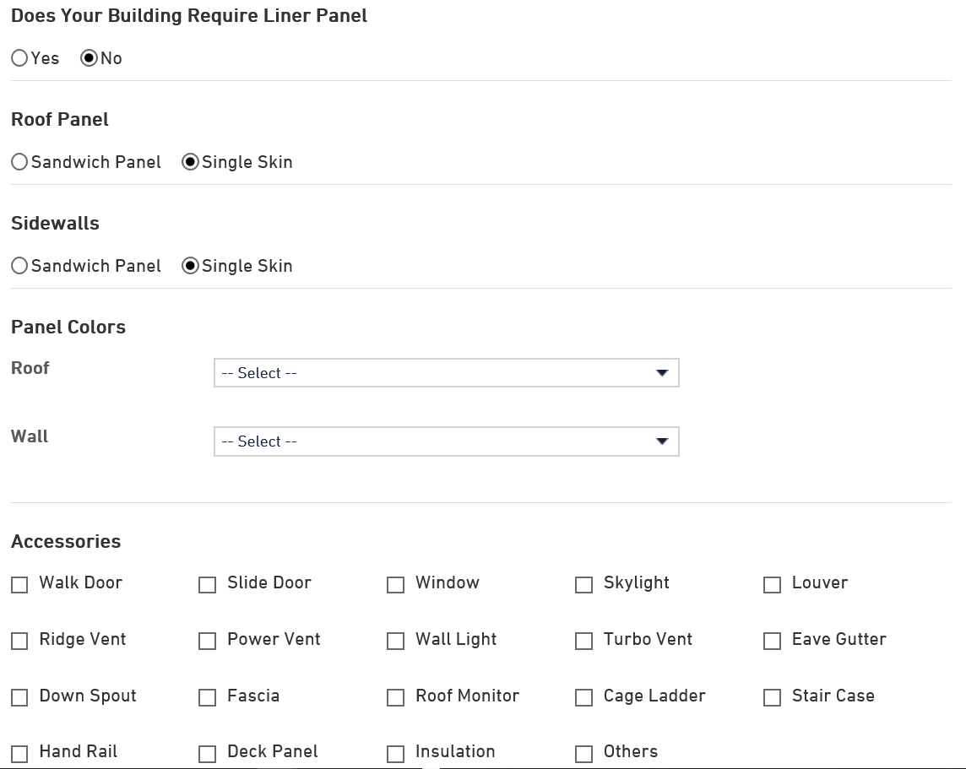



**PEB Raw Material**

1. Hot Rolled Coils/Plates

2. Cold Rolled Coils/Sheets

3. Bare Galvalume Coils

4. Pre-Painted Galvalume Coils

5. Pre-Painted GI Coils

6. Hot Rolled Builtup Sections

7. Hot Rolled Bars

8. Paints

9. Abrasive wheels

10. Welding Consumables

i. Flux

ii. Welding Wires

**Executive Team**

**Photo & description of Management, engineering, sales, Construction & logistics**

**PEB Trading**

1. Purlins / Girts

2. Eve Sturts

3. Roof Panel –Trepezoidal Profiled Sheet

4. Roof Panel – Standing Seam Profile Sheet

5. Wall Cladding Profiled Sheet

6. Trims & Flashing